\*\*\*TESTING WITH NO TOP HASH SAVED\*\*\*<Few Files>

==Top Hash== \*\*\* 0756d8fef133313e412141d53606d229 \*\*\*

No previous top hash exists...

New Top Hash Saved.

Process returned 0 (0x0) execution time : 0.021 s

Press any key to continue.

\*\*\*TESTING AGAIN NOW WITH SAVED TOP\*\*\*<Few Files>

==Top Hash== \*\*\* 0756d8fef133313e412141d53606d229 \*\*\*

Top hash is equal to previous.

No change found in files...

Process returned 0 (0x0) execution time : 0.019 s

Press any key to continue.

\*\*\*TESTING AGAIN NOW WITH CHANGE IN A FILE BEING CHECKED\*\*\*<Few Files>

==Top Hash== \*\*\* 1aae573f011d175f8dc47ff324be452e \*\*\*

...Files were changed!!!

Top Hash not the same as previous saved Hash!

Process returned -1 (0xFFFFFFFF) execution time : 0.051 s

Press any key to continue.

\*\*\*TESTING WITH NO TOP HASH\*\*\*<Large amount of Files>

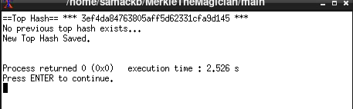

\*\*\*TESTING AGAIN WITH NO CHANGES\*\*\*<Large amount of Files>

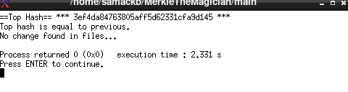

\*\*\*TESTING AGAIN WITH CHANGE TO RANDOM FILE\*\*\*<Large amount of Files>

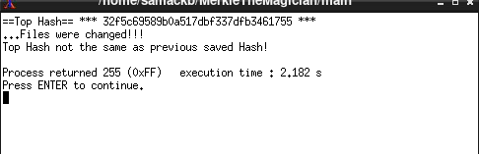

\*\*\*TESTING WITH FILE CHANGED BACK TO HOW IT WAS BEFORE\*\*\*<Large amount of Files>

